Das Gesicht → the face

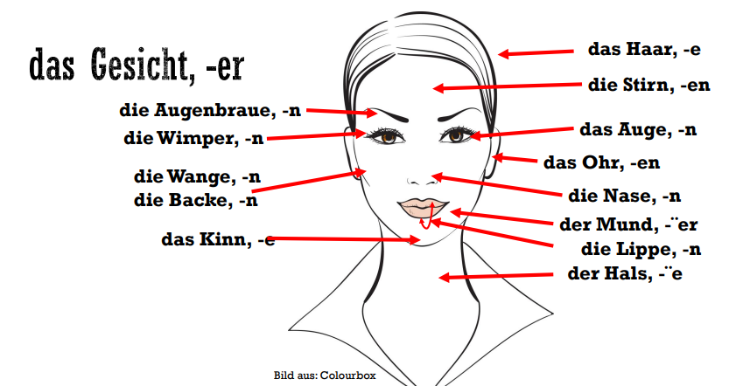

**Krankheiten und symptome → Diseases and symptoms**

Beschreiben Sie die Person? Wie fühlt er sich? → Describe the person? How does he feel?

**Es geht ihm nicht gut/schlecht***He is not feeling well/bad.*

**Es fühlt sich schlecht/krank***He feels bad/sick.*

**Er hat Fieber***He has a fever.*

**Er hat eine Erkältung***He has a cold.*

**Er ist sich erkältet***He caught a cold.*

**Er hat Schnupfen***He has a runny nose.*

**Seine Nase läuft***His nose is running.*

**Seine Nase ist verstopft***His nose is congested.*

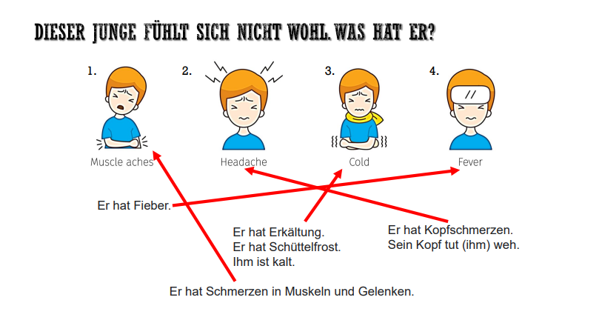

Schmerzen = pains

Gelenken = joints

Fieber = fever

Erkaltung = cold

Schuttelfrost = chills

**Ihm ist kalt = he is cold**

**Sein kopf tut weh → his head hurts**

**Er hat Kopfschmerzen → he has headache**

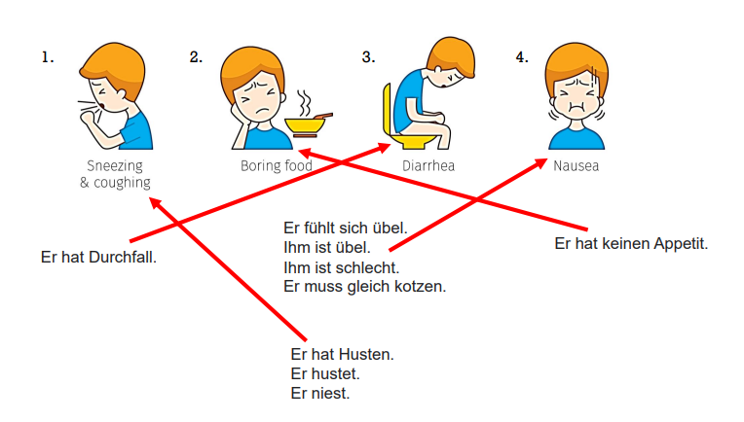

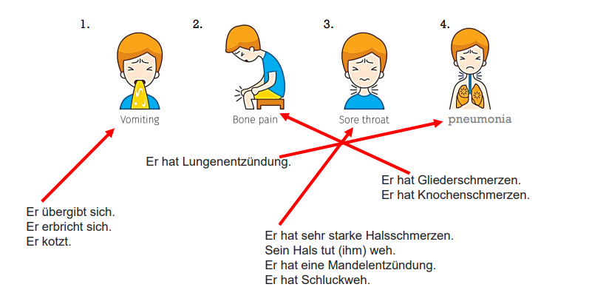

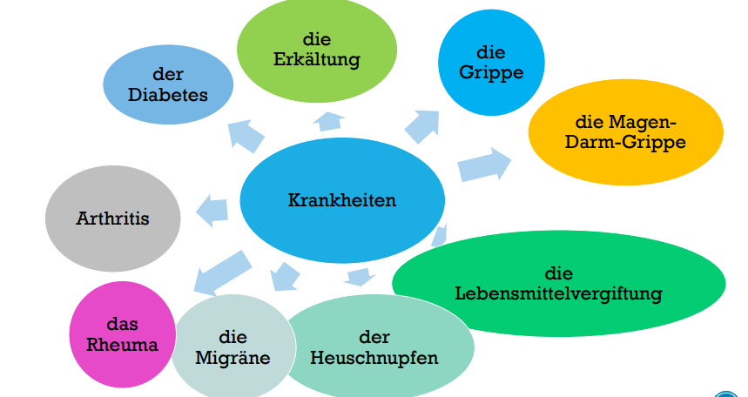

**"die Erkältung" = the Cold (common cold)**

**"die Grippe" = the Flu/Influenza**

**"die Magen-Darm-Grippe" = Gastroenteritis/Stomach flu**

**"die Lebensmittelvergiftung" = Food poisoning**

**"der Heuschnupfen" = Hay fever**

**"die Migräne" = Migraine**

**"das Rheuma" = Rheumatism**

**"Arthritis" = Arthritis**

**"der Diabetes" = Diabetes**

**Modalverben und ihre Bedeutung**

**Mussen**

Have to/ necessity, request or duty

Du musst (pos 2) jeden Tag Deutsch lernen (at end position). → You have to learn german everyday

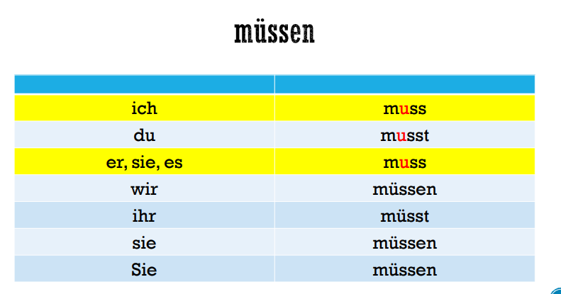

nicht + müssen = keine Pflicht, keine Notwendigkeit (es ist nicht nötig), kein Gesetz → not + have to = no obligation, no need (it is not necessary), no law

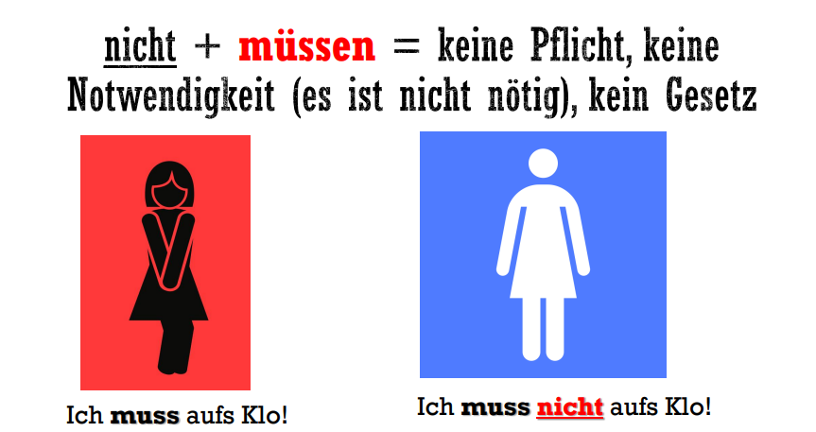

aufs klo → to the toilet

For mussen + nicht/kein/nur you can also use brauchen .

Du brauchst heute nicht zu arbeiten = du musst heute nicht arbeiten

Konnen

Konnen = can or the ability to see the possibility or how to do something

Ich kann schwimmen → i can swim

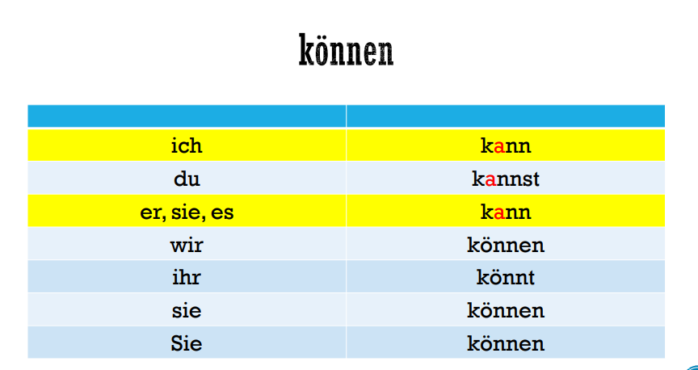

**Wollen (Want = der Wunsch, the will = der Wille, the intention = die Absicht)**

**Ich will heute abend ins kino gehen → i will go today evening to movie**

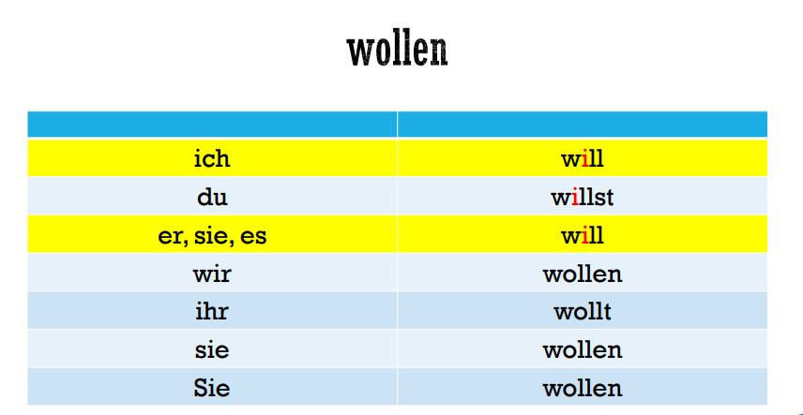

**Mochten → to wish something politely**

**Ich möchte jetzt nach Hause fahren → I want to go home now.**

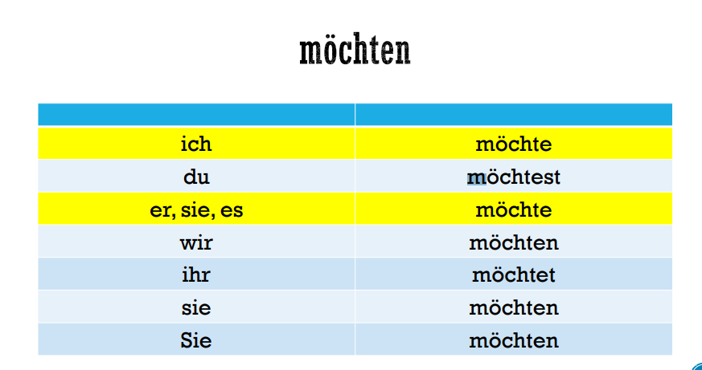

**Sollen → should / order or command**

**Der Arzt sagt, ich soll heute im bett bleiben → the doctor says that i should have to sleep in bed today**

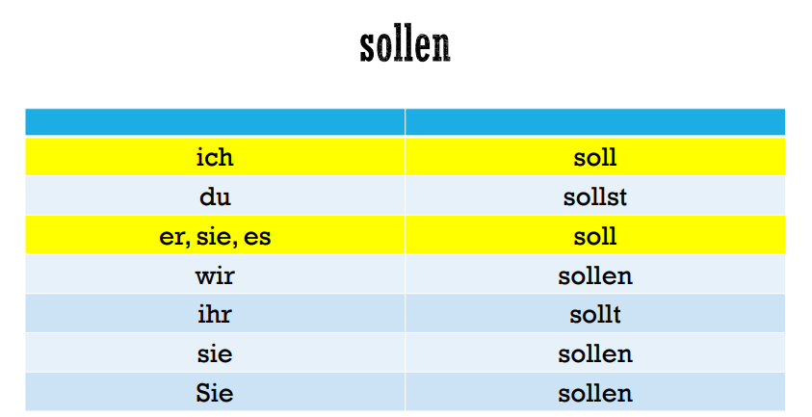

**Durfen (allowed / permission)**

**Ich darf hier rauchen → I can smoke here.**

**Es ist erlaubt → it is allowed**

**Nicht + dürfen = das verbot → not + allowed = ban**

**Ich darf hier nicht rauchen → I am not allowed to smoke here.**

**Es ist nicht erlaubt → its now allowed**

**Es ist verboten → its forbidden**

**Dürfen = besonders höfliche frage → May = particularly polite question**

**Darf ich deinen Pullover anziehen → can i put on your sweater**

**Darf ich dein Fahrrad leihen → May I borrow your bike?**

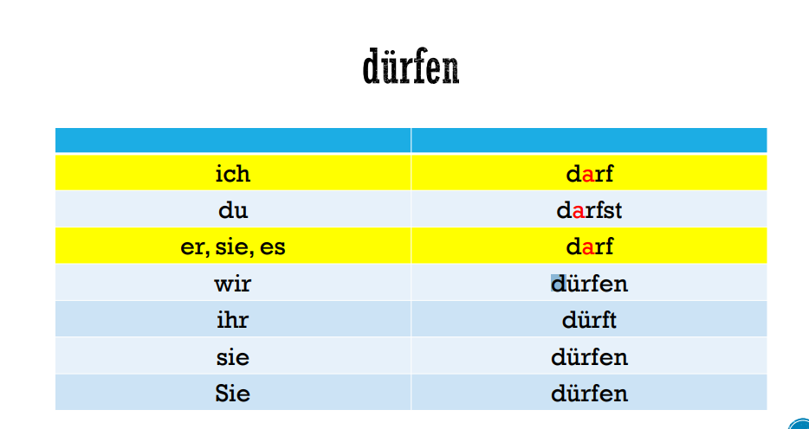

**der mann sagte : das kann man doch nicht machen → The man said: You can't do that**

**Was ist der Unterschied zwischen Mann und man? → what is the difference between Mann and man?**

**Der Mann is the man a masculine person**

**Man means all people / all men or women like indefinite pronoun**

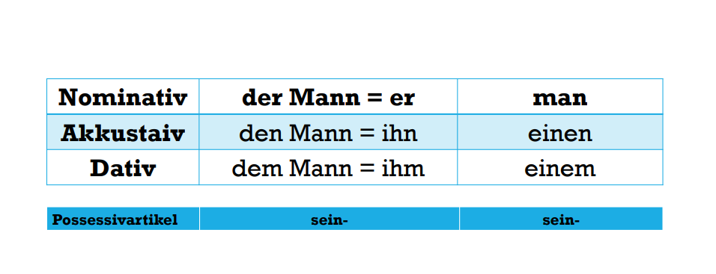

**Imperative**

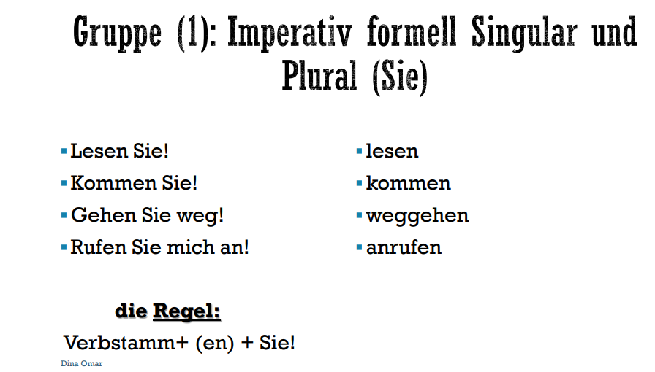

**This image explains the formal imperative (command) form in German using "Sie" - which is the formal "you" form used for politeness and respect.**

**Title Translation:**

**"Group (1): Formal Imperative Singular and Plural (Sie)"**

**The examples shown are:**

**1. "Lesen Sie!" = "Please read!" (formal)**

**2. "Kommen Sie!" = "Please come!" (formal)**

**3. "Gehen Sie weg!" = "Please go away!" (formal)**

**4. "Rufen Sie mich an!" = "Please call me!" (formal)**

**On the right side are the infinitive forms of these verbs:**

**- lesen (to read)**

**- kommen (to come)**

**- weggehen (to go away)**

**- anrufen (to call)**

**The Rule (die Regel):**

**"Verbstamm+ (en) + Sie!"**

**This means to form the formal imperative:**

**1. Take the verb stem**

**2. Add (en) if needed**

**3. Add "Sie" and an exclamation mark**

**This is the polite way to give commands in German, similar to saying "please do something" in English. It's important to note that unlike the informal imperative, the formal imperative keeps the "en" ending of the verb and always includes "Sie" after the verb.**

**The formal imperative is used when:**

**- Speaking to strangers**

**- Speaking to superiors**

**- In professional situations**

**- When showing respect or maintaining formality**

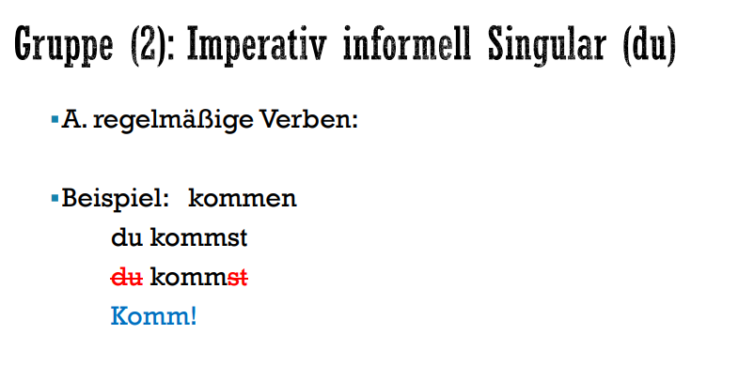

**This shows how to form informal commands (imperative) in German using "du" (informal "you").**

**Title: "Group (2): Informal Imperative Singular (du)"**

**The example demonstrates with the regular verb "kommen" (to come):**

**1. Infinitive: kommen**

**2. Present tense: du kommst**

**3. Command form: Komm!**

**The key is to take the "du" form of the verb (kommst), remove the "st" ending and "du", and you get the informal command "Komm!"**

**This form is used with:**

**- Friends**

**- Family**

**- Children**

**- Casual situations**

**It's much shorter and more direct than the formal "Sie" form we saw earlier.**

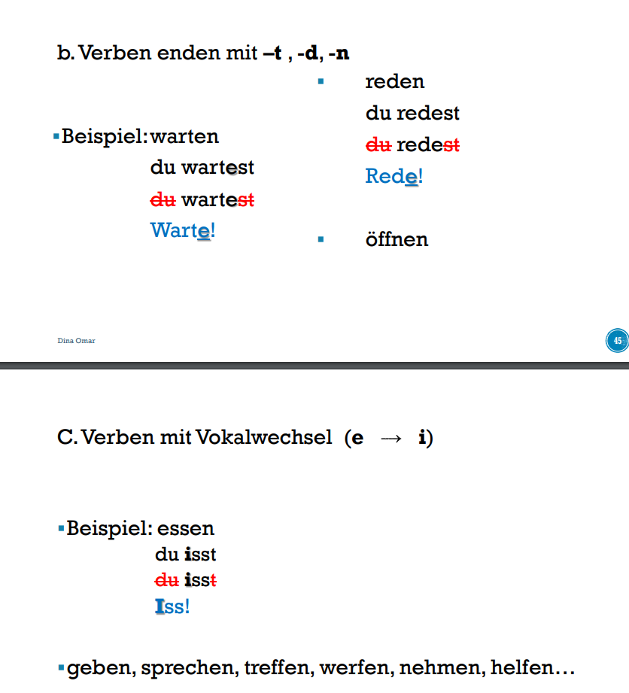

**Let me explain both sections quickly:**

**B. Verbs ending in -t, -d, -n:**

**Examples show:**

**- warten (to wait) → Warte! (Wait!)**

**- reden (to talk) → Rede! (Talk!)**

**- öffnen (to open)**

**The rule: When making commands with verbs ending in t, d, or n, add 'e' to make it easier to pronounce.**

**C. Verbs with vowel change (e → i):**

**Example shows:**

**- essen (to eat) becomes "Iss!" (Eat!)**

**Other verbs that follow this pattern:**

**geben (give), sprechen (speak), treffen (meet), werfen (throw), nehmen (take), helfen (help)**

**In these verbs, the 'e' changes to 'i' in the command form, just like it does in their present tense "du" form.**

**Translations of examples:**

**- Warte! = Wait!**

**- Rede! = Talk!**

**- Iss! = Eat!**

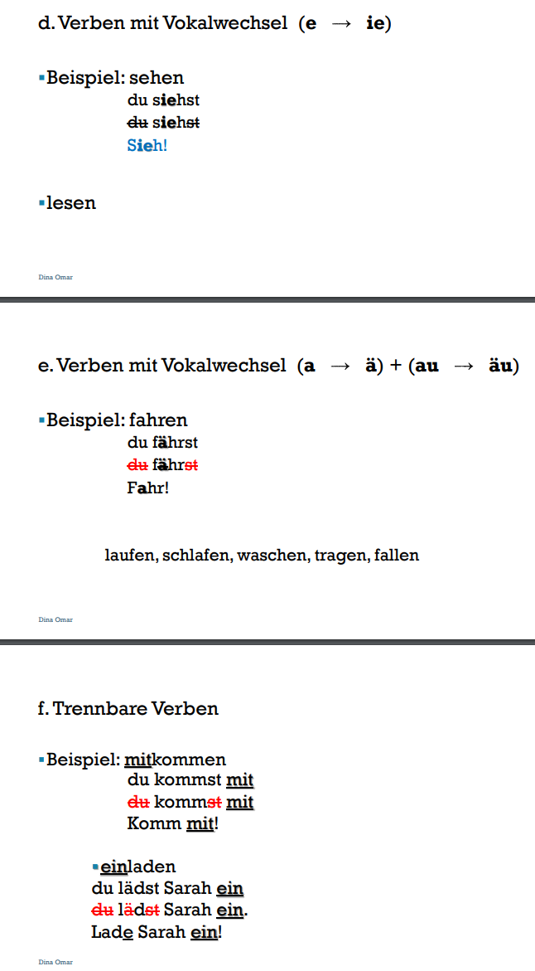

**Let me break these three sections down simply:**

**D. Verbs with vowel change (e → ie):**

**- Example: sehen (to see) → Sieh! (See!)**

**- Also applies to: lesen (to read)**

**- The 'e' changes to 'ie' in commands**

**E. Verbs with vowel changes (a → ä) and (au → äu):**

**- Example: fahren (to drive) → Fahr! (Drive!)**

**- Other verbs that follow this pattern:**

**- laufen (to run)**

**- schlafen (to sleep)**

**- waschen (to wash)**

**- tragen (to carry)**

**- fallen (to fall)**

**F. Separable verbs (Trennbare Verben):**

**- Example 1: mitkommen (to come along)**

**- Command: Komm mit! (Come along!)**

**- Example 2: einladen (to invite)**

**- Command: Lade Sarah ein! (Invite Sarah!)**

**- The prefix (mit-, ein-) separates and goes to the end in commands**

**Key point: Separable verbs split apart in commands, with the prefix going to the end of the sentence.**

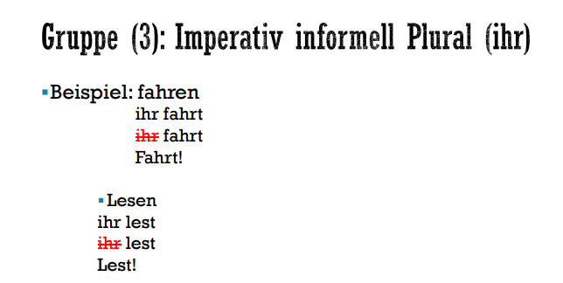

**This shows Group 3: Informal Plural Commands using "ihr" (you all/you guys)**

**Examples shown:**

**1. fahren (to drive)**

**- Regular form: ihr fahrt**

**- Command form: Fahrt! (Drive!/You all drive!)**

**2. Lesen (to read)**

**- Regular form: ihr lest**

**- Command form: Lest! (Read!/You all read!)**

**The rule is simple:**

**- Take the regular "ihr" form of the verb**

**- Remove "ihr"**

**- Add exclamation mark**

**- That's your command form**

**This form is used when giving informal commands to multiple people, like friends or family members. It's the plural equivalent of the informal "du" commands we saw earlier.**

**Translations:**

**- Fahrt! = Drive! (addressing multiple people informally)**

**- Lest! = Read! (addressing multiple people informally)**

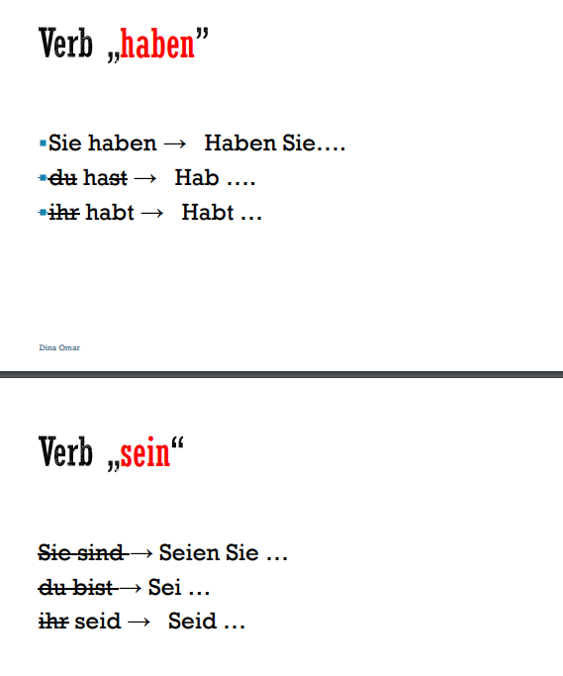

**This shows the imperative (command) forms for two important German verbs: "haben" (to have) and "sein" (to be).**

**For "haben":**

**1. Formal (Sie): Haben Sie... (Have...)**

**2. Informal singular (du): Hab... (Have...)**

**3. Informal plural (ihr): Habt... (Have...)**

**For "sein":**

**1. Formal (Sie): Seien Sie... (Be...)**

**2. Informal singular (du): Sei... (Be...)**

**3. Informal plural (ihr): Seid... (Be...)**

**These are irregular verbs, so their command forms don't follow the regular patterns we saw earlier. They need to be memorized separately as they're very commonly used in German.**

**Remember: These forms are essential for giving commands using "to be" and "to have" at different levels of formality and for different numbers of people.**

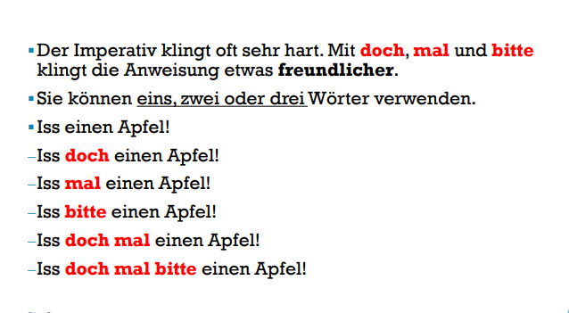

**This explains how to make German commands sound softer and more polite. Let me break it down:**

**The first line explains: "The imperative often sounds very harsh. With 'doch', 'mal' and 'bitte', the instruction sounds a bit friendlier."**

**You can use one, two, or three of these softening words together.**

**Using the example "Iss einen Apfel!" (Eat an apple!), here are the increasingly polite versions:**

**1. Basic command:**

**- Iss einen Apfel! = Eat an apple!**

**2. Softer versions using one word:**

**- Iss doch einen Apfel! = Do eat an apple**

**- Iss mal einen Apfel! = Just eat an apple**

**- Iss bitte einen Apfel! = Please eat an apple**

**3. Even softer with two words:**

**- Iss doch mal einen Apfel! = Why don't you eat an apple**

**4. Most polite with all three:**

**- Iss doch mal bitte einen Apfel! = Please do just eat an apple**

**This is similar to how in English we might say "please" or use phrases like "would you mind" to make requests more polite.**

